**Experiment No. 10**

Aim: To Perform File Transfer and Access using FTP using Packet tracer.

Requirements: Windows O.S and Cisco Packet Tracer.

Theory:

**What is FTP (File Transfer Protocol)?**

FTP (File Transfer Protocol) is a network protocol for transmitting files between computers over Transmission Control Protocol/Internet Protocol (TCP/IP) connections. Within the TCP/IP suite, FTP is considered an application layer protocol. In an FTP transaction, the end user's computer is typically called the local host. The second computer involved in FTP is a remote host, which is usually a server. Both computers need to be connected via a network and configured properly to transfer files via FTP. Servers must be set up to run FTP services, and the client must have FTP software installed to access these services.

**How does FTP work?**

FTP is a client-server protocol that relies on two communications channels between the client and server: a command channel for controlling the conversation and a data channel for transmitting file content.

Here is how a typical FTP transfer works:

1. A user typically needs to log on to the FTP server, although some servers make some or all of their content available without a login, a model known as anonymous FTP.
2. The client initiates a conversation with the server when the user requests to download a file.
3. Using FTP, a client can upload, download, delete and rename, move and copy files on a server.

Output:

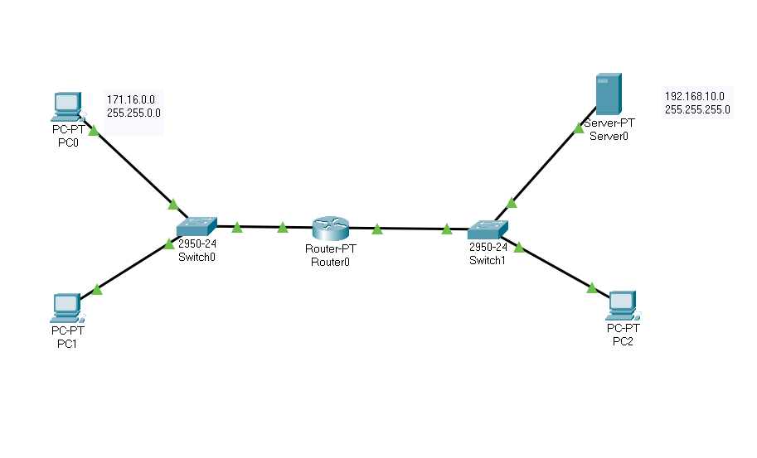

Uploading File (testing.txt) to the server from PC2 using FTP:

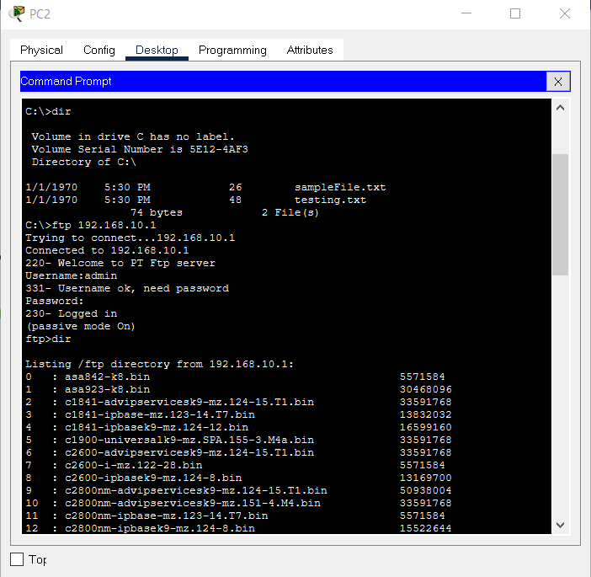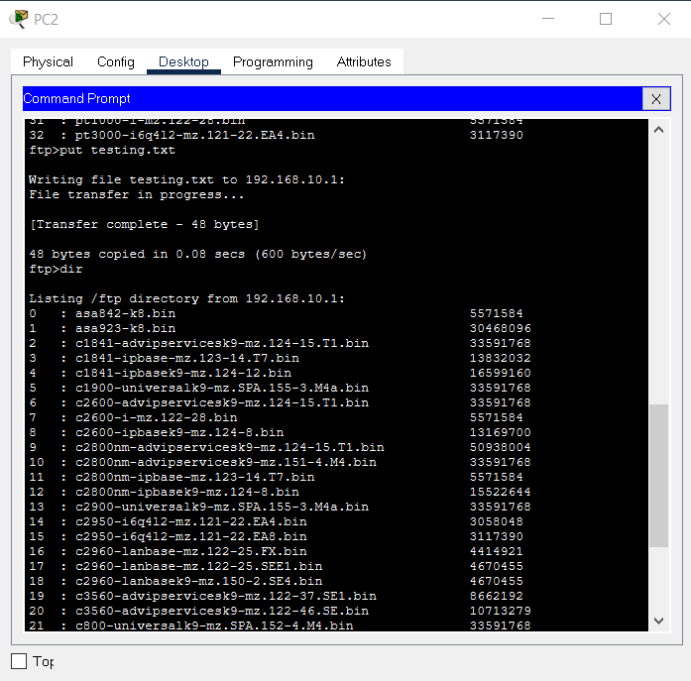

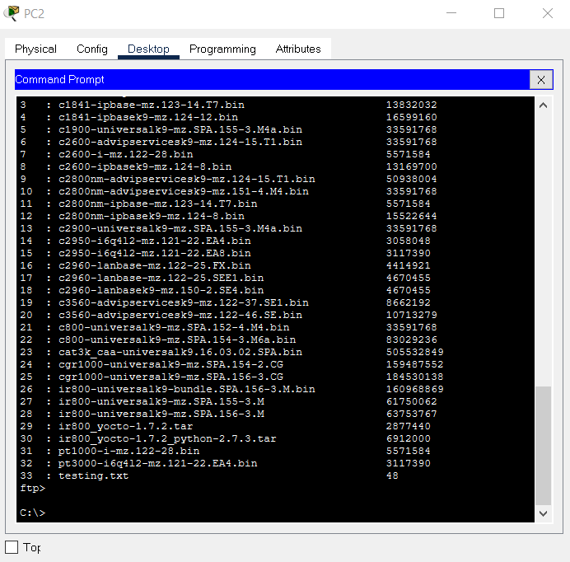\

Downloading testing.txt from server to PC0 using FTP:

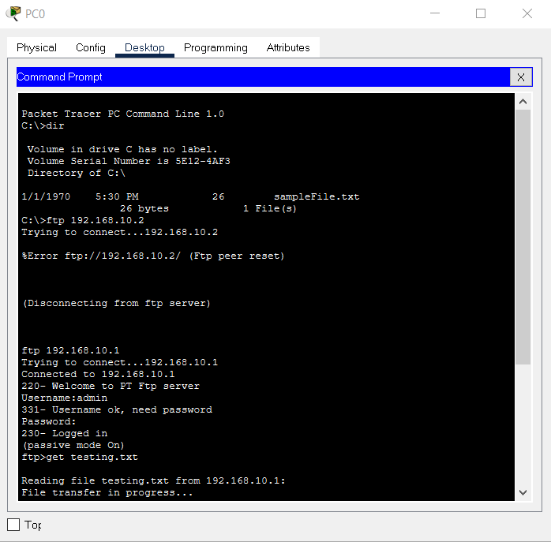

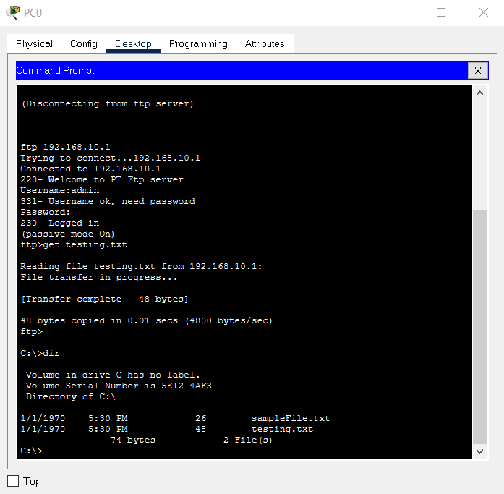

Downloading testing.txt from server to PC1 using FTP:

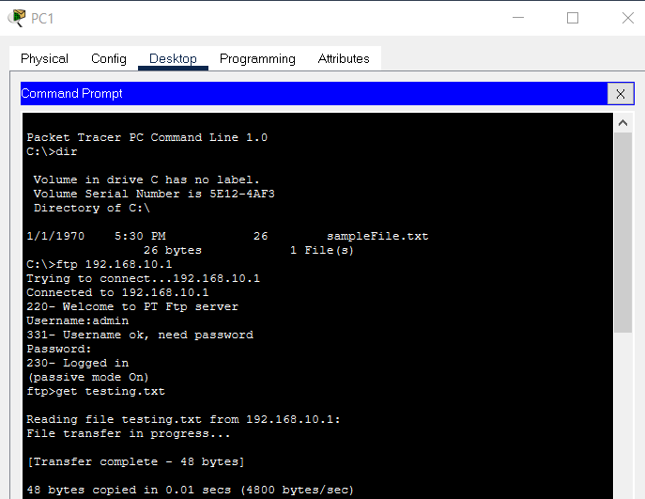

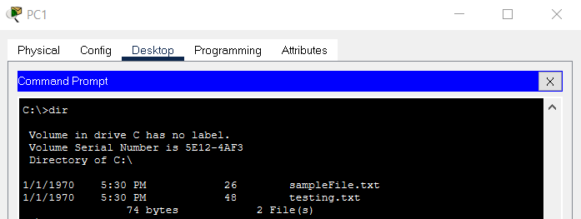

Conclusion: We have successfully access and transfer file from and to the server using FTP command in CISCO Packet tracer.